**Web Archive**

By: Nidhi Patel, Ahmed Alfaris, Zachary Wireman, Nathaniel Leonardo

Professor: Bruce Maxim

I. Table of Contents

**1. Introduction............................................................................................. 3**

1.1. Goals and objectives---------------------------------------------------------------- 3

1.2. Statement of scope------------------------------------------------------------------ 3

1.3. Software context---------------------------------------------------------------------- 3

1.4. Major constraints--------------------------------------------------------------------- 3

**2. Usage scenario....................................................................................... 4**

2.1. User profiles--------------------------------------------------------------------------- 4

2.2. User stories--------------------------------------------------------------------------- 4

2.3. Special usage considerations----------------------------------------------------- 4

**4. Functional Model and Description........................................................ 5**

4.1. Description for Function 1---------------------------------------------------------- 5

4.1.1.1 Use case name------------------------------------------------------------------ 5

4.1.2.1 Actors------------------------------------------------------------------------------- 5

4.1.3.1 Preconditions---------------------------------------------------------------------- 5

4.1.4.1 Triggers----------------------------------------------------------------------------- 5

4.1.5.1 Scenario Description------------------------------------------------------------ 5

4.1.6.1 Post Conditions------------------------------------------------------------------- 5

4.1.7.1 Exceptions------------------------------------------------------------------------- 5

4.3 Use Case Diagrams------------------------------------------------------------------ 6

**8. Appendices.............................................................................................. 7**

8.1. System traceability matrix---------------------------------------------------------- 7

1.0 Introduction

We are to develop a web archive that will allow visiting alumni / family and friends of alumni to access photos and student information of CECS graduates at the University of Michigan Dearborn. This web archive is to be accessed only through a kiosk located at the ELB building, which will allow users to search the database by name, major, degree level, graduation year, and graduation semester. Additionally to viewing such information, this application will also allow a visiting alumni to submit personal information to be vetted and included in the database upon approval from administration.

1.1 Goals and objectives

* The goal of the document is to provide a description of the functionality, necessary requirements, and performance of the web application we are creating.
* We want to increase usability of this website by developing a searchable database which have access to student information, and photos. Also provide access to users to add personal information.

1.2 Statement of scope

The user should be able to:

* Use the search feature to find student information easily
* View student information, such as
  + Name
  + Graduating year and semester
  + Major
  + Photo
  + Additional/post-graduation info
* Have access to add personal information and submit it for approval, than it will be added to the database
* Admin should be able to approve or decline the submitted request
* Admin can add new student information to the database

1.3 Software context

* This software will help people at U of M Dearborn search for and view graduated student information.
* In order to make the archive sustainable, we have to consider how we are going to make the website easier for the admin to add and edit student information.

1.4 Major constraints

* Time - We have to set out requirements, plan, develop, and test the archive all within 8 months. This is doable, but will be our main constraint for the project.

2.0 Usage scenario

2.1 User profiles

There will be two levels of users:

* Full Control (Administrator)
* Read/Search/Submit information (General Public)

2.2 User stories

**Full Control User:**

This is the system administrator level which will be able to change any application settings as well as update and maintain the database.

**Read/Search/Submit user information :**

This level of users will be able to search/read the database and cannot insert, delete or modify any information in the database, the only exception is this user can submit information to be added to the database upon approval from administration.

2.3 Special usage considerations

* Users must be able to view student information and request for changes when opening the kiosk
* Maintain consideration for users with color blindness in the UI design.
* Admins/users can edit the information and achievements.
* Make pop up notifications and other important elements large and clear to see for users  
  with visual impairments

4.0 Functional Model and Description

4.1 Description for Function

Note: In this context a profile is the database entry for one graduated student.

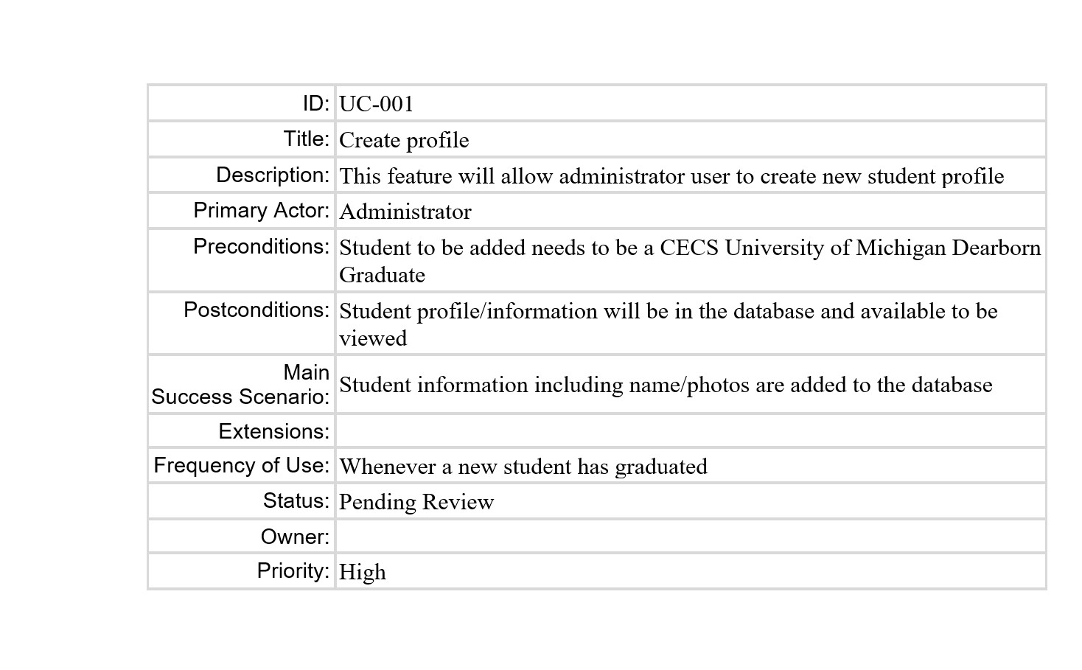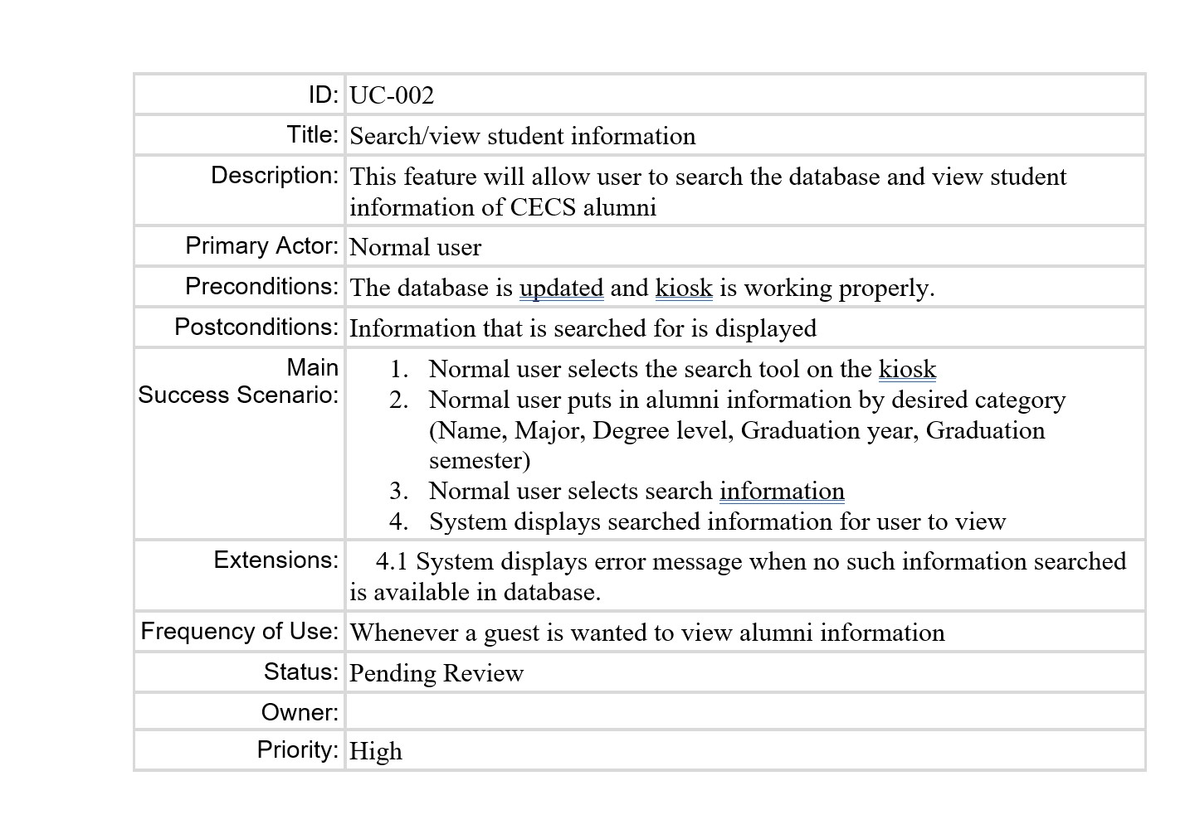

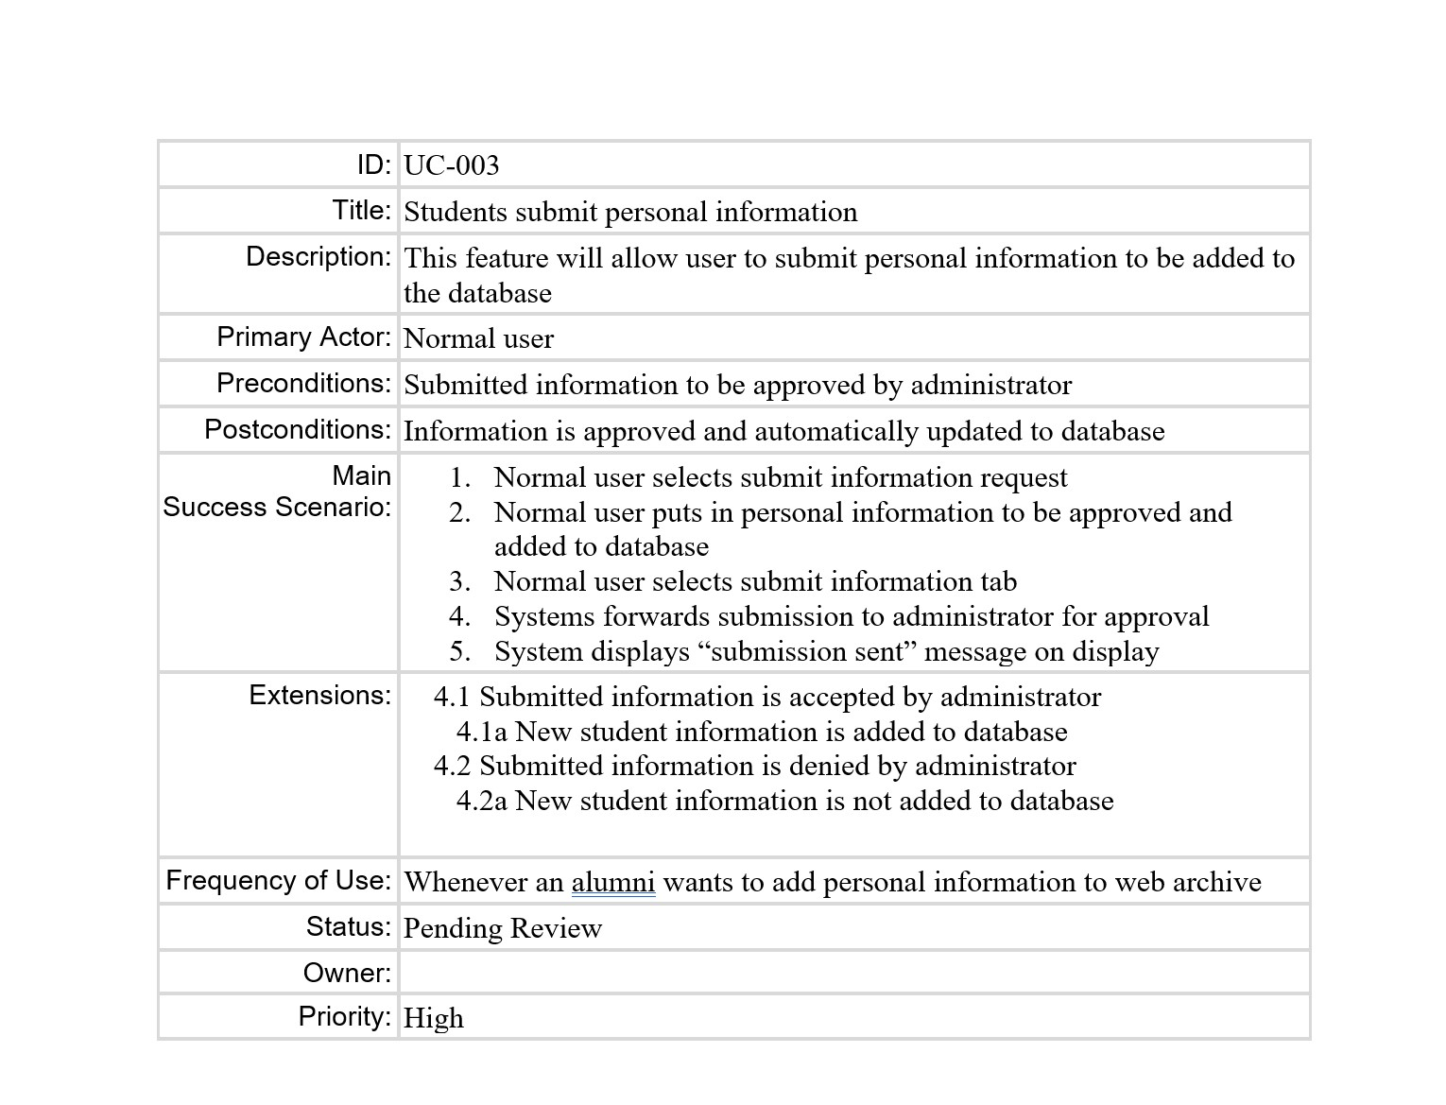

4.3 Use Case Diagrams

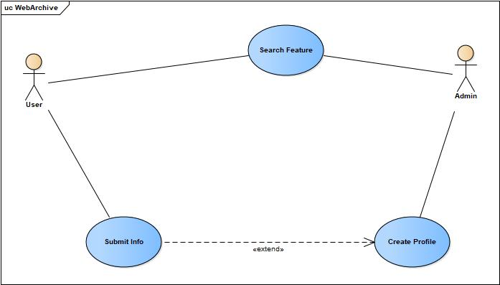

8.0 Appendices

8.1 System traceability matrix

| Key | ID | Test cases | Description | Request | Priority | Status |
| --- | --- | --- | --- | --- | --- | --- |
| 1 | UC - 001 | Search Feature | Users should be able to search by name, class,Major, Degree Level, Graduation year, and Graduation semester | Admin/Users | 5 |  |
| 2 | UC - 002 | Create Profile | Admin is allow to create new student profile | Admin | 5 |  |
| 3 | UC - 003 | Submit Info | User allow to makes changes upon admin approval | User | 5 |  |

Document template from: [APM Documents](http://www.rspa.com/docs/index.html)